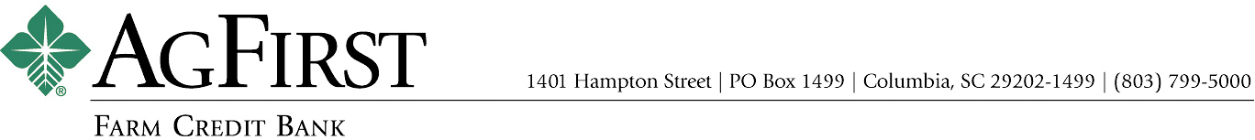

NEWS RELEASE Contacts:
Donna J. Camacho, Director of Communications
dcamacho@agfirst.com; 803-753-2251
Joy M. Upchurch, Vice President-Marketing
jupchurch@agfirst.com; 803-753-2379

for release

Thursday, December 20, 2007

AgFirst Farm Credit Bank Announces
Results of Director Elections

Columbia, s.c.— At recent director elections, Gary L. Alexander of Westminster, S.C., James M. Norsworthy, III of Jackson, La., and Dale R. Hershey of Manheim, Penn., were elected to the AgFirst Farm Credit Bank board of directors for four-year terms. Re-elected to the board were Robert G. Sexton of Vero Beach, Fla., and Paul M. House of Nokesville, Va. Retiring from the board are Dale W. Player of Bishopville, S.C., a Farm Credit Bank director since 1990, Paul Lemoine of Plaucheville, La., a Farm Credit Bank director since 1988, and Richard Kriebel of Benton, Penn., a Farm Credit Bank director since 1990.
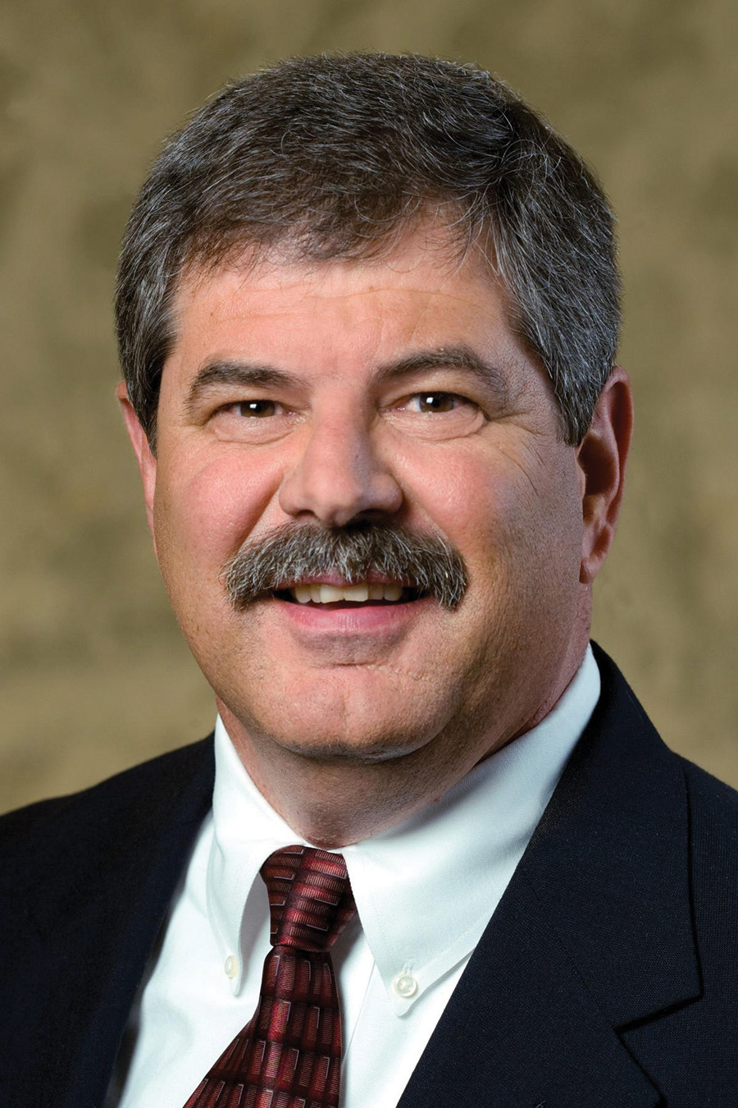
Gary L. Alexander
Alexander is owner and operator of Alexander Farms, Inc., a poultry production and property development business in Seneca, South Carolina. He markets 3.2 million broilers a year through his
18-broiler house farm and develops residential properties. A civil engineering graduate of Clemson University, he currently serves on the board of directors of AgSouth Farm Credit and is a member of the audit committee. Alexander is currently a member of the S. C. Poultry Federation and was chairman of its board of directors from 2003 to 2004.
James M. Norsworthy, III
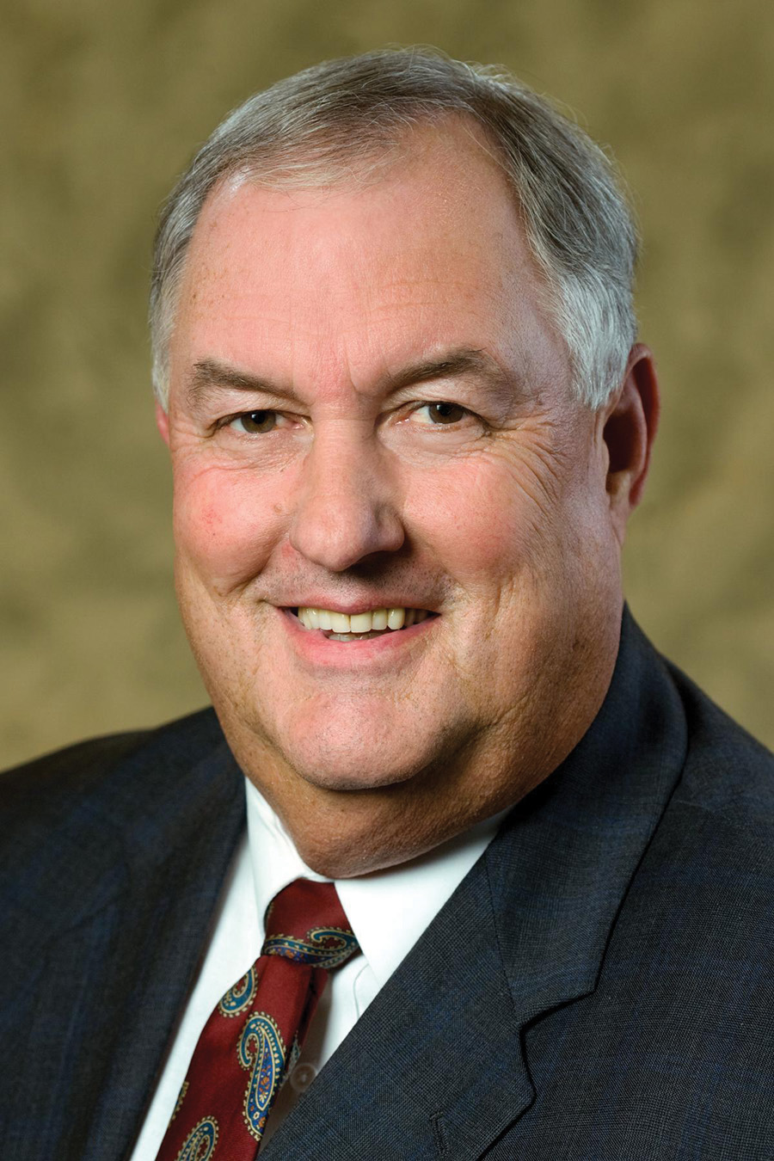
Involved in production agriculture for 38 years, Norsworthy runs 100 Cedars Cattle Farm, a 175-head cow-calf operation near Jackson, La. He also has a commercial hay operation with 125 acres in Alicia Bermuda hay and 150 acres in Bahia Grass hay and manages a 375-acre pine and hardwood timber operation. A graduate of Louisiana State University with a Bachelor’s degree in Vocational Agricultural Education, he is a member of the board of directors of First South Farm Credit, headquartered in Ridgeland, Miss. Norsworthy also serves on the board of Feliciana Farm Bureau and was president of that organization from 1984 to 1996. He is a member of East Feliciana Cattlemen’s Association, American Angus Association and the Feliciana Forestry Association. Norsworthy served as mayor of the town of Jackson, La., from 1979 to 1996.
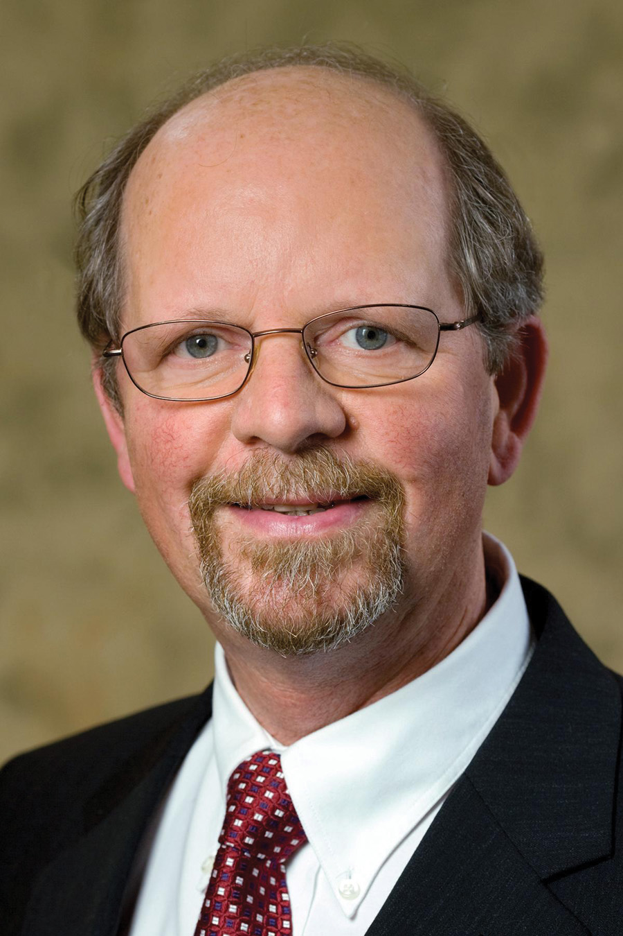
Dale R. Hershey
Hershey is a partner in Hershey Brothers Dairy Farms in Manheim, Penn., a dairy operation which milks 285 cows, raises 250 dairy replacements, and grows 650 acres of corn, alfalfa, soybeans, barley, rye and hay. Hershey graduated from Penn State University with a Bachelor’s degree in Community Development and a Masters’ degree in Ag Economics and Rural Sociology. He serves as vice-chairman of the board of directors of MidAtlantic Farm Credit, headquartered in Westminster, Md. Hershey is a delegate on the Leadership Council for Land O’Lakes and is a member of Pennsylvania Farm Bureau, Pennsylvania Dairy Stakeholders and the Pennsylvania Holstein Association. Hershey also is a member of the Lancaster County Blue Ribbon Commission for Agriculture and the Penn Township Ag Advisory Committee.
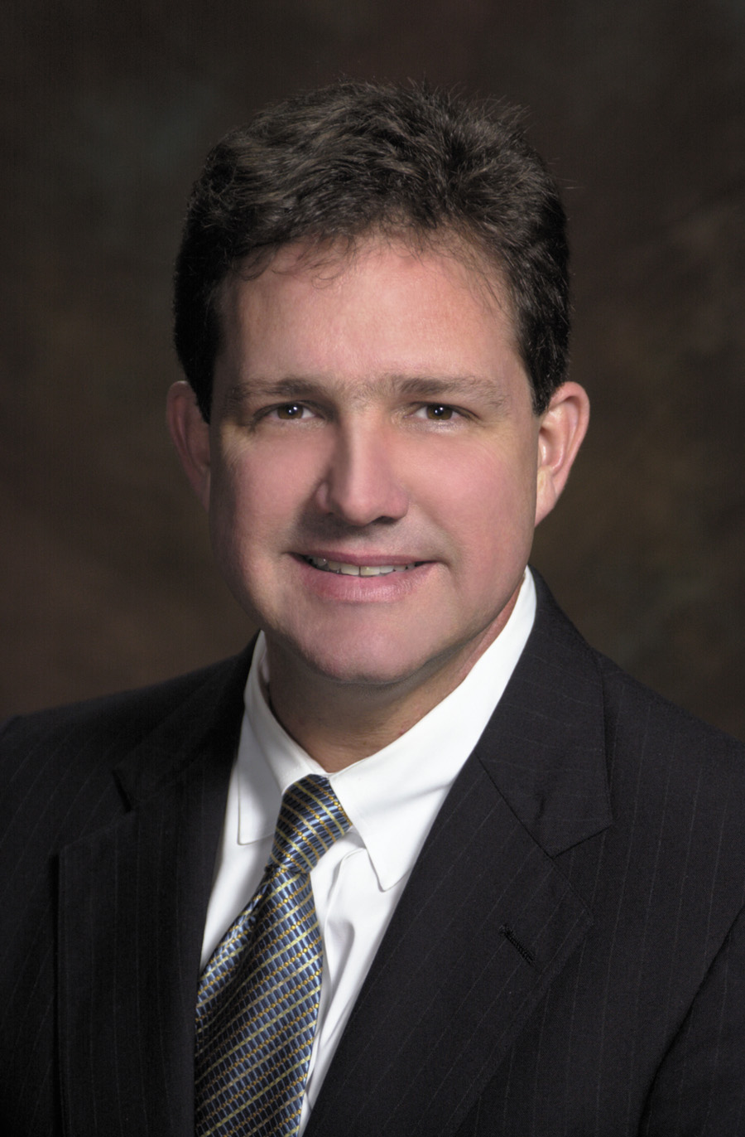
Robert G. Sexton
Sexton, a life-long citrus grower in Vero Beach, Fla., is president of Oslo Citrus Growers Association. He grows citrus on 400 acres with his brother and sister and also operates a fresh fruit packing house. Sexton is also co-owner of Orchid Island Juice Company and vice president of Oslo Packing Company, a family-owned commercial real estate company. He also is owner, director and vice president of Dancing Pigs, LLC, a restaurant. Sexton serves on the boards of Farm Credit of South Florida, headquartered in Royal Palm Beach, Florida; McArthur Farms, a dairy, cattle and citrus agribusiness; Sexton Grove Holdings, a family citrus company; Sexton, Inc. and Sexton Properties, both family commercial real estate companies. He is a member of Florida Citrus Mutual, Farm Bureau, Indian River Citrus League and Florida Citrus Packers. He has a Bachelor’s degree in business administration and an MBA in Finance from the University of Florida. Sexton has been a member of the AgFirst board of directors since 2000.
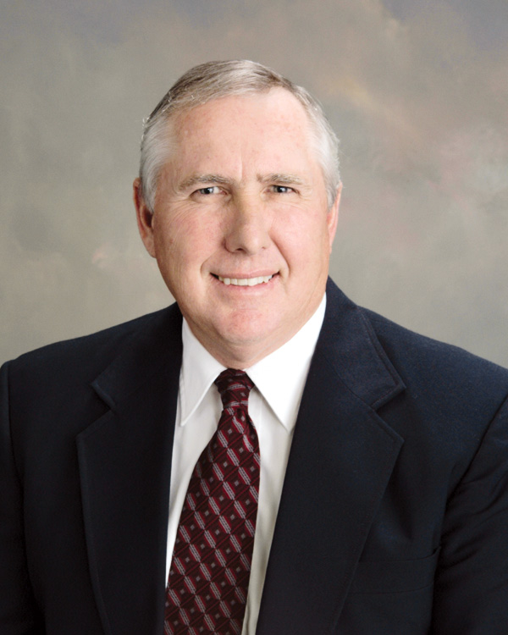
Paul M. House
House manages Kettle Wind Farm located in Nokesville, Va., which includes 3,500 acres encompassing a 280-cow and 270-replacement-heifer dairy operation, 1,000 acres in soybeans, 1,400 acres in turf grasses and 1,130 acres in corn, hay and wheat. He attended Glenville State College in Glenville, W. Va. House serves on the board of directors of Farm Credit of the Virginias, headquartered in Staunton, Va. He is also a member of the Virginia Farm Bureau, Maryland and Virginia Milk Producers, Virginia State Dairymen’s Association, Southern States and Genex. He has served on the AgFirst board of directors since 2003.

Other members of the bank board are: William C. Bess, Jr., Lincolnton, N.C.; Henry M. (Buddy) Frazee, Alachua, Fla.; Don W. Freeman, Montgomery, Ala.; Robert L. Holden Sr., Whigham, Ga.; Thomas W. Kelly, Tyrone, Penn.; Lyle Ray King, Ash, N.C.; M. Wayne Lambertson, Pocomoke City, Md.; James L. May, Waynesburg, Ky.; Eugene W. Merritt Jr. Easley, SC.; Katherine A. Pace, Orlando, Fla.; J. Dan Raines, Jr., Ashburn, Ga.; Walter L. Schmidlen, Jr., Elkins, W.Va.; Kenneth A. Spearman, Winter Haven, Fla.; Robert H. Spiers, Jr., Stony Creek, Va.; and William H. Voss, McComb, Miss.

###

About AgFirst Farm Credit Bank (www.agfirst.com): AgFirst Farm Credit Bank provides funding and financial services to 23 Agricultural Credit Associations (ACAs) in 15 eastern states and Puerto Rico. These associations, operating as Farm Credit and Ag Credit associations, provide real estate and production financing to more than 80,000 farmers, agribusinesses, and rural homeowners. AgFirst reported assets of $26.5 billion as of September 30, 2007.
AgFirst is part of the Farm Credit System, a nationwide network of agricultural and rural lending institutions cooperatively owned by their borrowers. Farm Credit helps maintain and improve the quality of life in rural America and on the farm, through its constant commitment to competitive lending, expert financial services and a feeling of partnership with its customers. The Farm Credit System reported combined assets of $179.5 billion on September 30, 2007.

